Notes: Enzymes

Vocabulary Words that go with enzymes: enzyme, digestion, synthesis, metabolism, activation energy, substrate, catalyst, active site, enzyme substrate complex, product, efficient, minimum, maximum

Function: lowers activation energy of reactions so less energy is needed (more efficient metabolism), aids in digestion and synthesis

Characteristics of Enzymes:
- Made of amino acids (they are proteins)
- Reusable
- Shape determines function (if the substrate does not fit the active site, no reaction or a slowed reaction will take place)
- Specificity: they are specific, 1 enzymes, 1 substrate
- When named (with few exceptions like pepsin and trypsin), the name is made of the substrate + -ase at the end
Activation Energy:

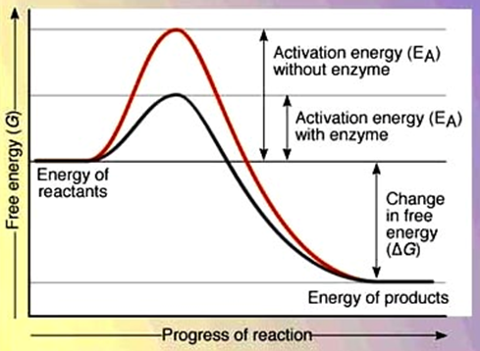

Lock and Key Model:

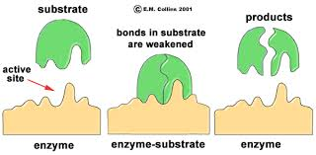
Vocabulary associated: rate, pH, temperature, maximum, range, optimal (optimum), denaturation, condition(s)

What is rate of enzyme activity? How fast the reaction happens

So what can affect the rate at which an enzyme works?

pH: a pH out of the enzymes optimal range will cause a change in shape of the enzyme and its activity will slow down or it will no longer work

Graph: 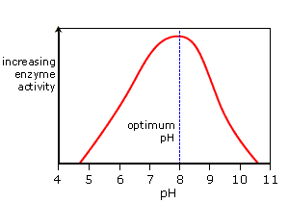

Temperature: a temperature out of the enzymes optimal range will cause a change in shape of the enzyme and its activity will slow down or it will no longer work

Graph: 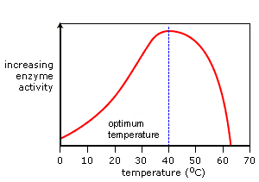

Concentration: If there is an increase in the concentration of the enzyme, activity will increase (more workers gets a job done faster)…. Graph 1. If there is an increase in the substrate that needs to be broken down, activity will increase until all the enzymes are being used up and then it will level off.(graph 2)

Graphs:
